ECNU and Kyushu University Hold Online Symposium on Education Disciplines for Thirty-third Anniversary of Partnership
On September 28, 2021, Faculty of Education of East China Normal University and School of Education, Graduate School of Human-Environment Studies, Kyushu University, Japan, successfully held an online seven-hour academic symposium, which included two sessions in the morning and afternoon respectively to celebrate the 33rd anniversary of two universities’ partnership. The main speakers from Kyushu University were Professor Takekuma Hisao, Dean of School of Education, Professor Fujita Yuhi, Head of Department of Educcation, Graduate School of Human-Environment Studies, Professor Nonomura Toshiko, Associate Professor Eguchi Kiyoshi, Associate Professor Chen Sicong, Associate Professor Suzuki Atsushi and a master student Takakura Yui. The attendees of ECNU were: Professor Yang Fuyi, Associate Dean of Graduate School of ECNU, Associate Professor Shen Ye, Deputy Secretary of the Party committee of the Faculty of Education, Professor Wu Zunmin and Associate Professor Li Lin of Department of Education Science, , Dean and Professor Zhou Bin, Professor Shen Xiaomin, of College of Teacher Education, Associate Professor Ma Lihua of Institute of Vocational and Adult Education, Qiu Yue, Director of International Affairs Division, Ding Tiantian of Teaching Affairs Division, doctoral student Cao Honglei of Institute of Higher Education and so on. The two sides conducted an academic discussion focusing on “Teacher Education Adapting to the New Era”, and jointly discussed the opportunities and challenges in education that China and Japan faced and updated the new reform researches in teacher education in two universities.
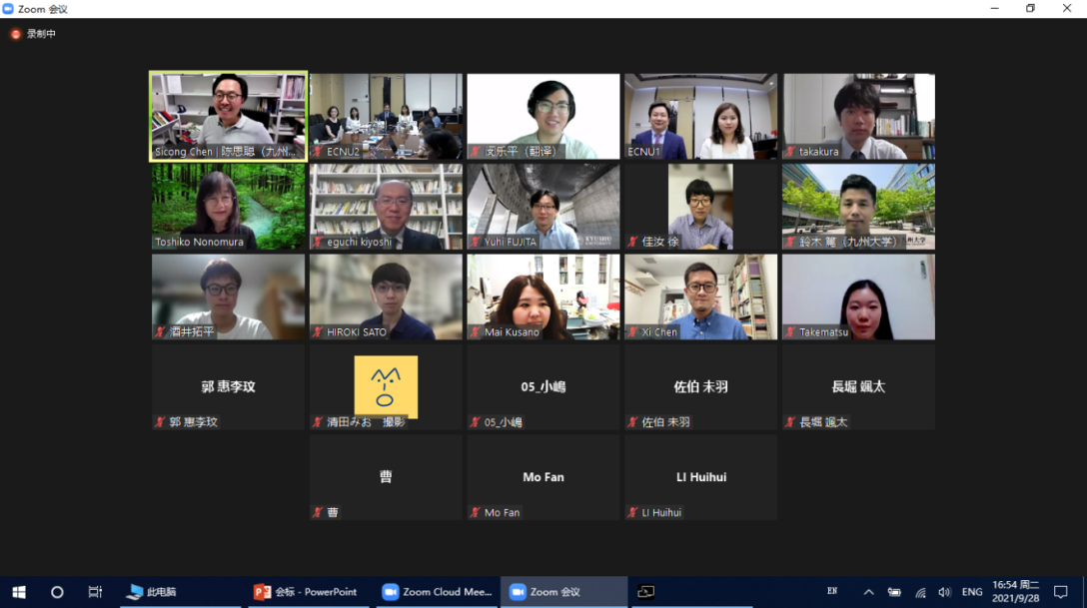
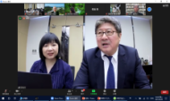

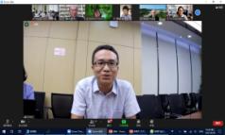
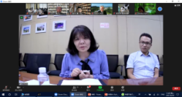
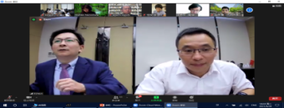
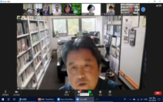
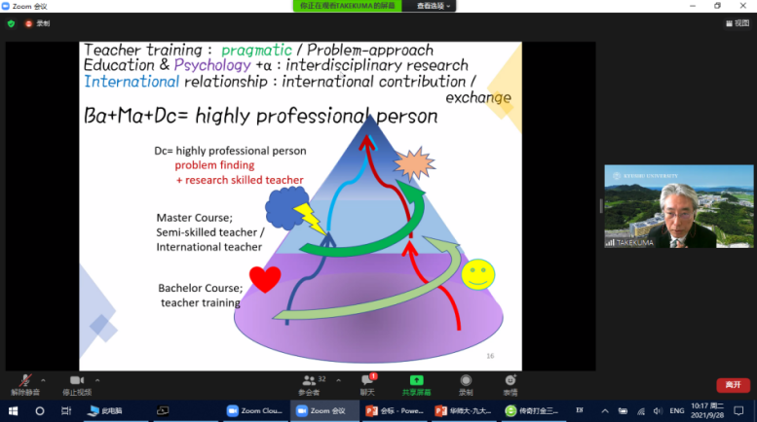
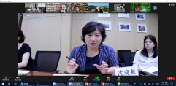

Participants of the 2021 Online Academic Symposium
Participants online

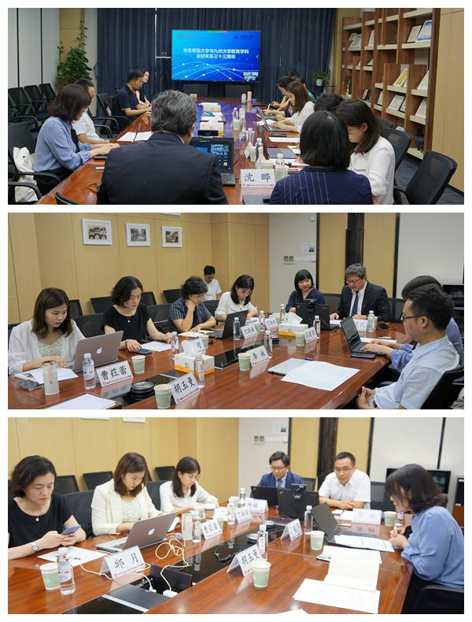
Participants of ECNU and the offline venue
At the beginning of the symposium, Professor Fujita Yuhi, on behalf of Kyushu University, expressed his gratitude to the participants and his regret for not being able to communicate face-to-face due to the epidemic. He mentioned that the 33rd anniversary of the friendly relationship between the two universities is a historical heritage and the joint efforts achievement of both sides. Professor Wu Zunmin of ECNU, the host of the morning meeting, in his opening speech, expressed his opinions as an important participant in these exchanges and his witness to the great efforts made by scholars for the international exchanges and education discipline development between the two sides during the past decades. He also reviewed the 33-year friendly partnership between ECNU and Kyushu University in education discipline, which originated from the two predecessors who promoted the establishment of partnership, Professor Kanda Osamu of School of Education of Kyushu University and Professor Jin Yiming of School of Educational Science of ECNU., and he glad to see that their efforts has passed on and blossomed through the generations of teachers and students in mutual exchanges and cooperation between the two universities.
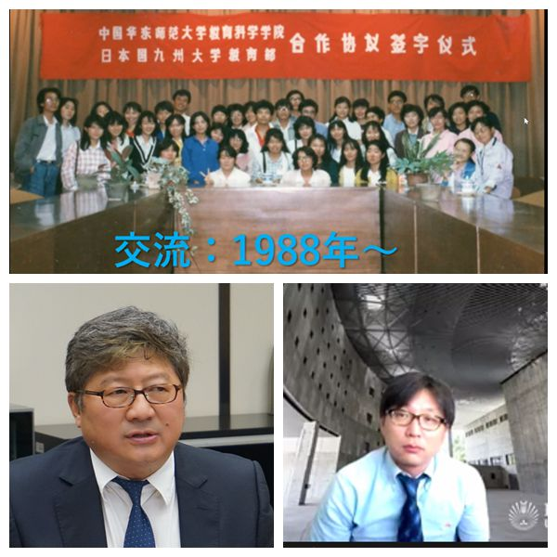
Professor Wu Zunmin of ECNU(the left), Professor Fujita Yuhi of Kyushu University(the right), delivering opening speech
On behalf of the Faculty of Education of ECNU, Associate Professor Shen Ye, Deputy Secretary of the Party committee of Faculty of Education extended warm welcome and heartfelt thanks to the participants. She introduced the status quo of the Faculty of Education, with the focus on the reform and practical results of student cultivation in the past four years. And she shared its philosophy, goals and explorations on how to cultivate future education leaders in line with the needs of social development.
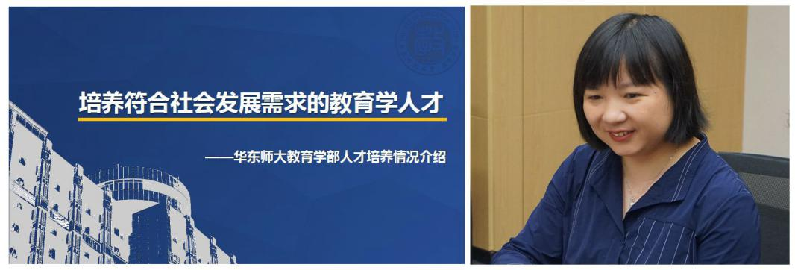
Associate Professor Shen Ye, delivering the report on “Cultivating Social Needed Educational Talents”

Professor Takekuma Hisao introduced discipline and personnel composition as well as talent cultivation of Kyushu University on the title of “A New Discussion on the Relevance between the School of Education and Teacher Education----Redesign Based on Educational Content and Educational Methods” .
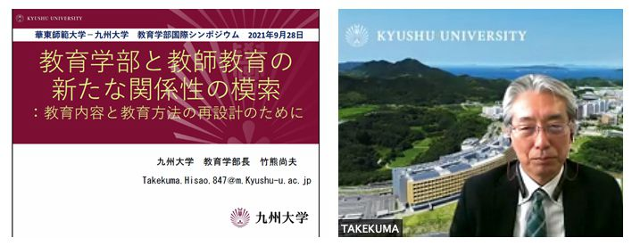
Professor Takekuma Hisao, delivering a report

Professor Wu Zunmin made a conclusion on the two reports, and expressed opinions on the impact of population policy and education development. Afterwards, Professor Shen Xiaomin, Associate Professor Li Lin, and Associate Professor Ma Lihua shared their experiences in the Sino-Japanese exchanges and had a discussion with the professors of Kyushu University on the theme of teacher education, including interdisciplinary research, ECNU’s Five One-Hundred practical education modes (one hundred innovative entrepreneurial activities, one hundred student associations, one hundred extracurricular research projects, one hundred social professional volunteer activities, one hundred “shadow principle”), ECNU’s Fonian Innovative Educational Researchers Cultivation Project, English teachers’ cultivation for primary and secondary schools, and the ratio of the number of graduate students and undergraduates, etc.
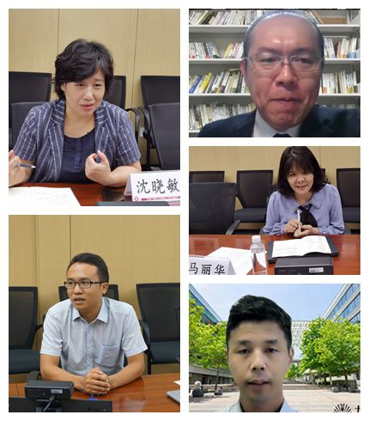
Hot discussion at the online symposium

In the afternoon, four keynote speeches and reports were delivered by the teachers and students in sequence. The hosts were Professor Nonomura Toshiko and Associate Professor Chen Sicong from Kyushu University. Associate Professor Eguchi Kiyoshi made a speech on “the Reform of Teacher Education in Japan and the Status Quo of Teacher Education in Kyushu University”, including the main content of the overall structure of Japanese teacher education, the acquisition of junior and high school teacher qualification certificates, the changes in teacher development system and professional environment, etc. He focused on the reform of teacher education in Kyushu University, especially the integration with existing educational practice to lay a solid foundation for practical teaching ability.

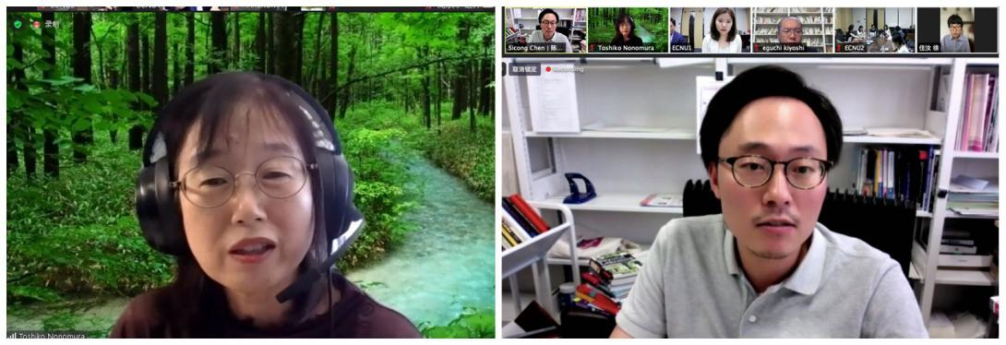
Professor Nonomura Toshiko and Associate Professor Chen Sicong from Kyushu University, as hosts in the keynote speeches

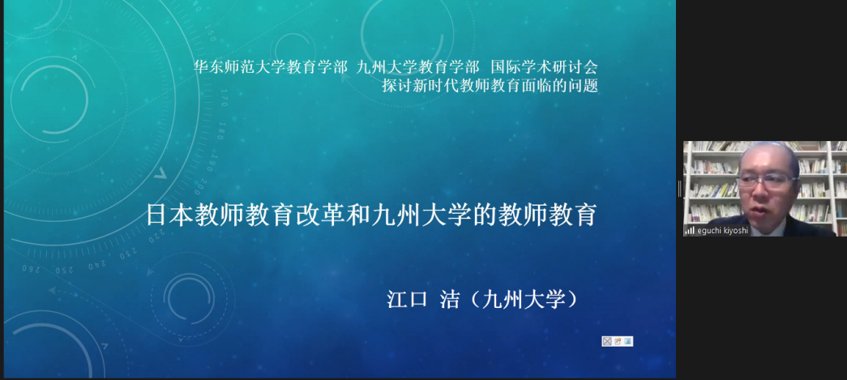
Associate Professor Eguchi Kiyoshi from Kyushu University, delivering a keynote speech
Professor Zhou Bin, Dean of College of Teacher Education of ECNU, gave a keynote speech titled "Core Issues and Choices for Revitalizing Teacher Education". Issues such as education and information technology, the types of knowledge produced and disseminated by teachers, and the higher level of teacher education were analyzed in his provoking elaboration.
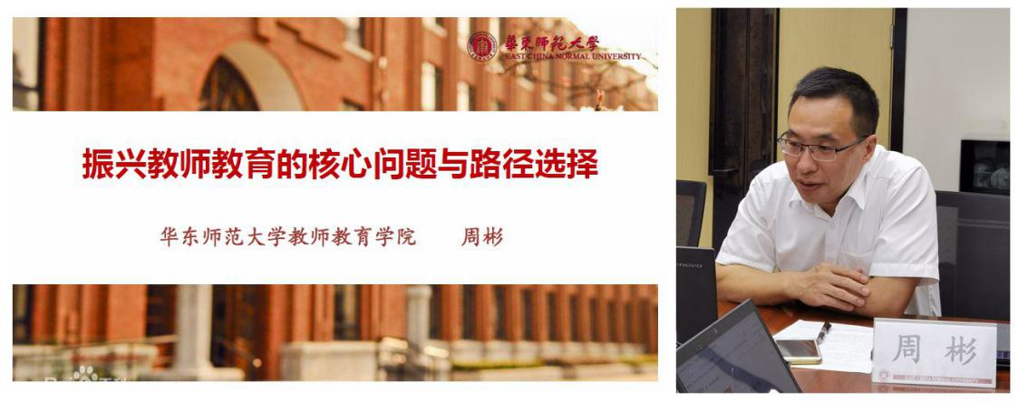
Professor Zhou Bin of ECNU, delivering a keynote speech

Based on the above keynote speeches, the participants in the meeting discussed and exchanged opinions on the motivations of teacher education reform, as well as reforms in Special Education in Japan, the application of information technology in teaching, and the structure of rural teachers in China.

Master student Takakura Yui of Kyushu University, made his report about the correlation research and findings on subject learning ability and competence from the perspective of school sociology. He pointed out that students’ learning awareness and attitude affect their subject learning, thus, teachers need to provide students with continuous and systematic tutoring during the class. When cultivating abstract abilities, activity-based teaching methods are easier to adopt. However, in order to cultivate students' competence, in many cases, teaching methods based on classroom activities are used, which also mean that teachers' active tutoring becomes much more difficult.
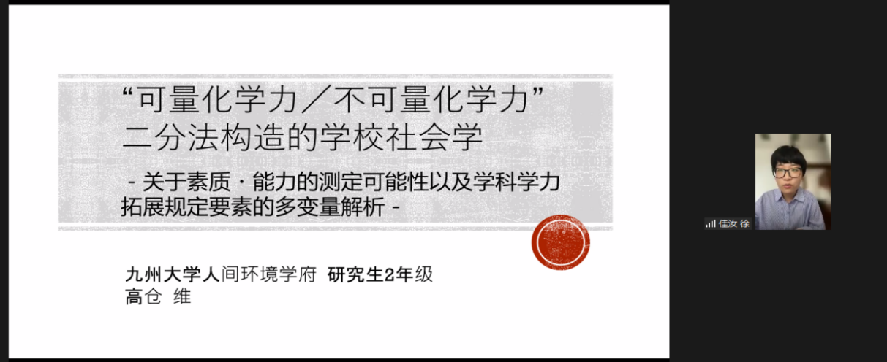
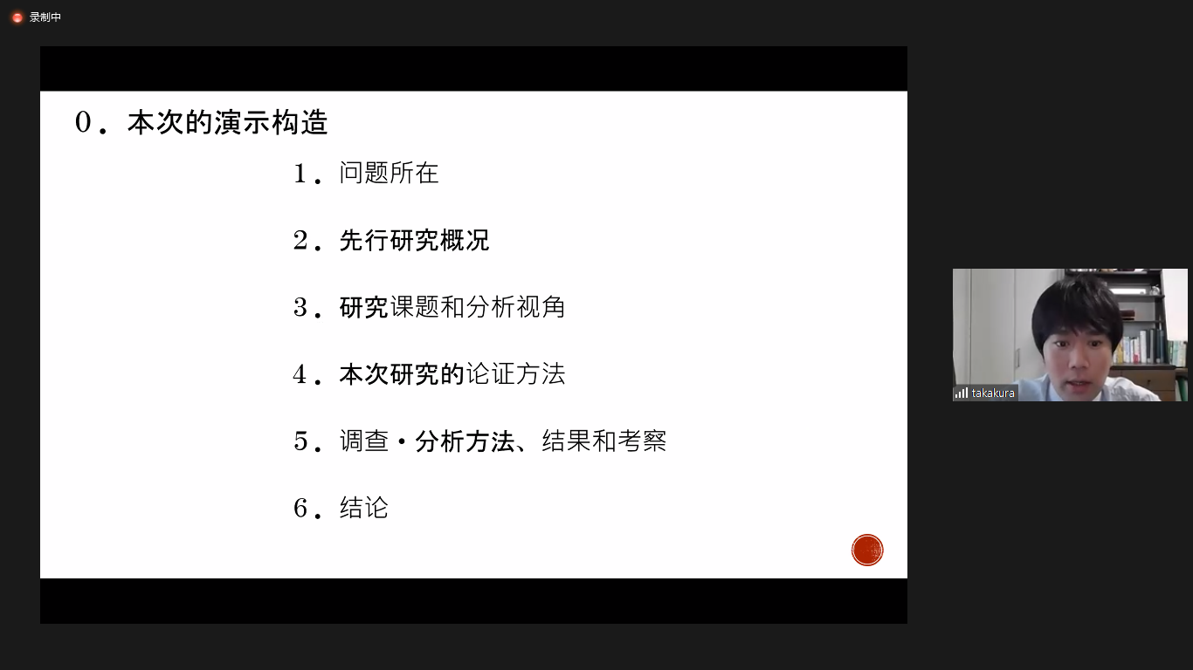

Master student Takakura Yui, delivering a report

Cao Honglei, a doctoral student of East China Normal University, gave a report titled "Pre-service Teacher Education under the Popularization of Higher Education: Realistic Dilemmas and Solutions". She analyzed that after the realization of higher-level teacher education, various unsettled dilemmas from concept, system, grading and teaching influenced by all aspects from higher education system emerged. In response to these dilemmas, combined with the functions of higher education and the logic of teacher education specialization, she proposed possible solution strategies.

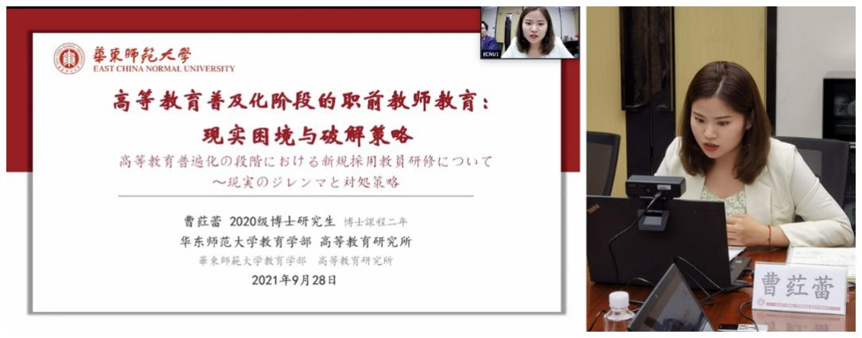
Cao Honglei of ECNU, delivering a report

Professor Yang Fuyi of ECNU and Associate Professor Suzuki Atsushi from Kyushu University made comments on students’ reports. They fully appreciated the research literacy of the two students and their academic potential as young scholars, and raised questions about the method, content and conclusions of the reports respectively.
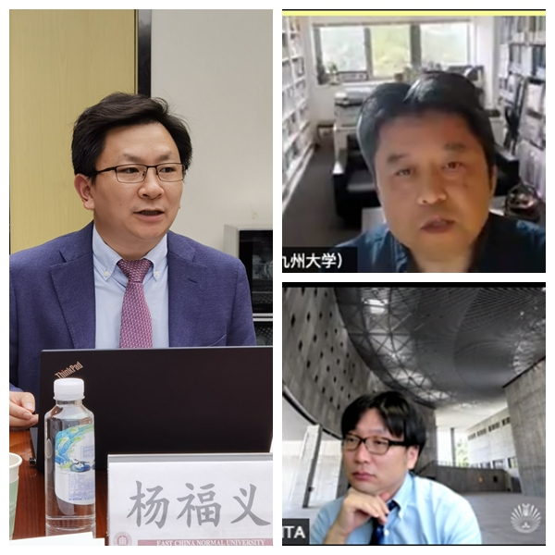
Questions and comments

Finally, in the conclusion session, Professor Nonomura Toshiko from Kyushu University expressed her gratitude to all participants for these sharing and exchanges, and showed her deep impression on Professor Zhou Bin’s report She believed that although certain conclusions had not been reached on what kind of the professional knowledge teachers should acquire, critical thinking was indispensable for learning of knowledge, as well as the development and reform in education. She is looking forward to further exchanges and communications. Professor Yang Fuyi made a concluding speech on behalf of ECNU. He appreciated the participants of both sides for their enthusiasm and rewarding discussion on teacher education. Then he highlighted the important practices of ECNU’ education discipline in international cooperative research and interdisciplinary research recently: as the sole representative of China, ECNU participated in the “Study on Social and Emotional Skills” organized by OECD and released series evaluation reports on Chinese youths’ social and emotional skills; And meanwhile, the Institute of Shanghai Intelligence Education, jointly established by ECNU and Shanghai Municipal Government, is carrying out interdisciplinary research combining artificial intelligence and education. During the epidemic, online academic meeting would strengthen the friendship between the two sides and promote in-depth exchanges in the future, which would further enhance the collaborations in academic research and talent cultivation. He hopes that the epidemic will end soon, and welcomes teachers and students of Kyushu University to ECNU to carry out face-to-face academic exchanges as before the epidemic.
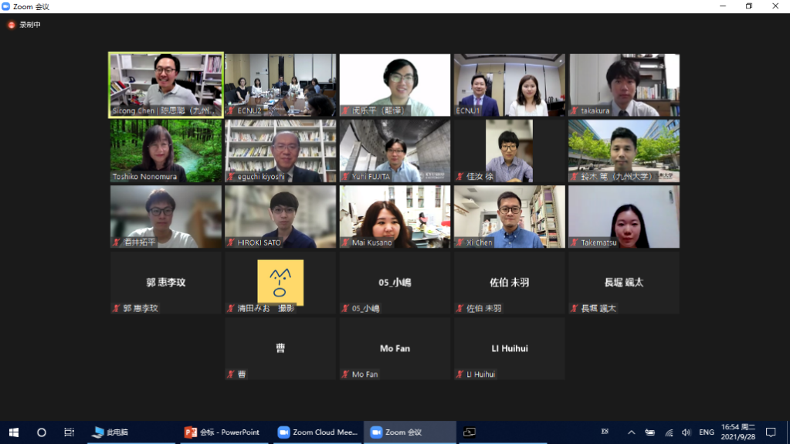

In 1988, the two universities firstly established cooperative relationship in education disciplines, and in 2005 and 2012 respectively established cooperation in history and foreign languages. Nearly 20 students have joined the program since a university level student-exchange program was signed in 2013. In January 2019, ECNU’s President Qian Xuhong led a delegation to visit Kyushu University and facilitated the signing of a formal university-level partnership agreement.

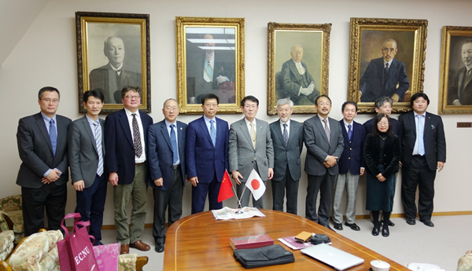

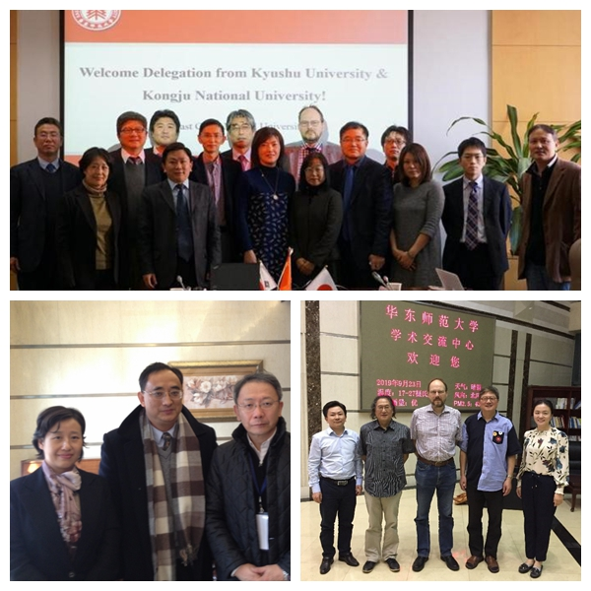
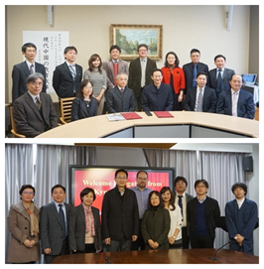

Since 2016, the Faculty of Education of ECNU and School of Education of Kyushu University have conducted on-site exchanges activities for four consecutive years, by holding academic exchange meetings and on-site visiting educational institutions. The academic exchange themes were involved in various research fields of education, including Development of Chinese Special Education, Children and Family from Historical Perspective, The Classical Tradition of Western Educational ideology, Japan's National University Entrance System and Equality, Examination and Appointment in China in the Late Imperial System, Educational Policy, Comparison of Educational Policies in Britain, America and Japan, Development of Chinese Preschool Education from an International Perspective, Enrollment and Examination System of Higher Education Institutions in China, Educational Reform in Modern China, Achievements and Prospects of Chinese Community Education in the Past Thirty Years, The Formation of the Modern Chinese School System at All Levels, Modernization and Education in Japan, Preschool Education in Japan, Cooperation Between Communities and Schools, Comparison of Entrance Examinations For Japanese and Chinese Universities, and so on.

